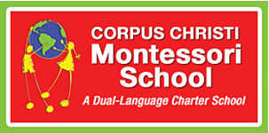

March 12, 2020

Dear CC-Montessori Families,

Many of you have reached out to the administration with concerns about the Coronavirus. As always, our students, their families, and the staff are our highest priority. In order to keep your students and families as safe as possible, we are extending our Spring Break through March 22nd.

During this time our campus and individual classrooms will be thoroughly cleaned and disinfected. Our staff will meet Monday, March 16th to finalize a plan to implement additional safeguards to foster good health and ensure your children’s education is not compromised due to the extenuating circumstances. Grade level work will be available via the school website and in the front office Monday afternoon until 4 p.m.

I know many of you will have questions related to our change in schedule as well as the steps we are taking to safeguard against illness. Please monitor updates as they are posted on our school website, School Facebook page, Parents of CC-Montessori Facebook page, the Remind App and email. Please ensure our staff has your most up-to-date email address. If you have specific questions, please email cerise@cc-montessori.org. While I may not be able to respond to individual emails, please be assured I will update our school website and provide answers as soon as possible.

I encourage everyone to follow the guidance provided by the CDC to minimize the spread of contagious illness and to practice frequent handwashing. While we cannot require our families to stay in the local area, we strongly recommend doing so to help keep our community safe once school begins.

As always, we appreciate your support. Stay healthy and safe.

Respectfully,

Cerise Weeks

