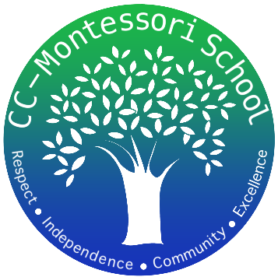
Corpus Christi Montessori School
A Free Public Charter

822 Ayers Street
Corpus Christi, Texas
(361) 852-0707
www.cc-montessori.com
SPECIAL ED DIRECTOR

Charter School
Corpus Christi Montessori School (a Public Charter School) 1st-8th
822 Ayers St., Corpus Christi, Texas 78404: 361-852-0707
Contact: Cerise Weeks Email: cerise@cc-montessori.org
Ada Flores Email: ada@cc-montessori.org

Title
Special Ed Director (Part Time or Full Time)

Salary
Pay will be based on experience

Duty Days
187 includes

Start Date
August 2022

Subject Area/Teaching Field Endorsement
Oversee the Special Education Program.
Provide Special Education services in a Montessori setting.
Plan and facilitate RTI, 504, & ARDs.
Plan and organize student evaluations.
Meet with teachers and parents.

Description
School Year 2022-2023

Requirements (Additional Information)
Bachelor's degree from accredited university
Valid Texas teaching certificate with required endorsements or required training for subject and level assigned

Application available online:
https://www.cc-montessori.com/employment

Close Date
Open until filled

Qualifications:
- Excellent organizational skills.
- Demonstrate a positive work attitude and have the ability to establish and maintain excellent relationships with staff, parents, and students.
- Demonstrate the tracking of student progress.
- Dedication to understanding and supporting the Montessori philosophy and methodology.
- Successful utilization of key Montessori concepts into practice.
- Work closely and collaboratively with Lower and Upper Elementary and Middle School team members.
- Ability to work well with a diverse group of students and parents, and to work as a TEAM PLAYER within the school community to create a strong professional learning environment.
- Strong work ethic with excellent communication and presentation skills.
Creative, inspirational, self-directed, positive, and committed with a “can-do attitude”.
- Willing to learn from and work well with fellow faculty members.

